ENGINEERING DRAWING

**SEMESTER PROJECT REPORT**



**LAB PROJECT REPORT**

**SUBJECT: -**

**ENGINEERING DRAWING**

SUBMITTED BY:

**M Abdullah Iqbal**

SUBMITTED TO:

**LE MISS SEHRISH FIRDOUS**

SUBMISSION DATE:

July 19, 2022

**Project Content:**

* 1 floor
* 1 Kitchen
* 2 rooms

**Project overview:** It is 3d project and basically most of it will be outer designed. In which realistic view will be given and renderings and automation will be used.

**Description:**

It is a single story house. It consists of two rooms, 1 kitchen and there is a roof top.

Now we will move towards Floor planning.

**Measurements**:

All measurements are in **centimeters**, and **the** measurements are taken according to online project. And onward I briefly add snips of measurements also

**Floor Planning in 2D:**

Floor planning is in 2D workspace and mostly components used are

* Line, polyline, rectangle, break, array, trim, modify, dimensions, offshoot, fillet, move, copy, snap grid, dynamic inputsetc.

Now we use command of lines, and offshoot and dimensions to make it

**COMMANDS :**

Command: _line

Specify first point:

Specify next point or [Undo]: <Ortho on> 8600

Command: _line

Specify first point:

Specify next point or [Undo]: 7600

offset:

Command: _offset

Current settings: Erase source=No Layer=Source OFFSETGAPTYPE=0

Specify offset distance or [Through/Erase/Layer] <Through>: T

Select object to offset or [Exit/Undo] <Exit>: T

*Invalid selection*

Expects a point or Exit

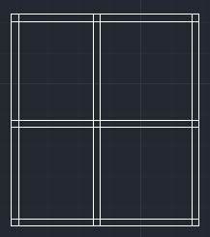

Select object to offset or [Exit/Undo] <Exit>:

Specify through point or [Exit/Multiple/Undo] <Exit>: 300

Select object to offset or [Exit/Undo] <Exit>:

Specify through point or [Exit/Multiple/Undo] <Exit>: 300

Select object to offset or [Exit/Undo] <Exit>:

Specify through point or [Exit/Multiple/Undo] <Exit>: 3000

Select object to offset or [Exit/Undo] <Exit>:

Specify through point or [Exit/Multiple/Undo] <Exit>: 300

Select object to offset or [Exit/Undo] <Exit>:

Specify through point or [Exit/Multiple/Undo] <Exit>: 3700

Select object to offset or [Exit/Undo] <Exit>:

Specify through point or [Exit/Multiple/Undo] <Exit>: 300

Select object to offset or [Exit/Undo] <Exit>:

Specify through point or [Exit/Multiple/Undo] <Exit>: 4000

Select object to offset or [Exit/Undo] <Exit>:

Specify through point or [Exit/Multiple/Undo] <Exit>: 300

Select object to offset or [Exit/Undo] <Exit>:

Specify through point or [Exit/Multiple/Undo] <Exit>: 3700

Select object to offset or [Exit/Undo] <Exit>:

Specify through point or [Exit/Multiple/Undo] <Exit>: 300

Select object to offset or [Exit/Undo] <Exit>:

Select object to offset or [Exit/Undo] <Exit>:

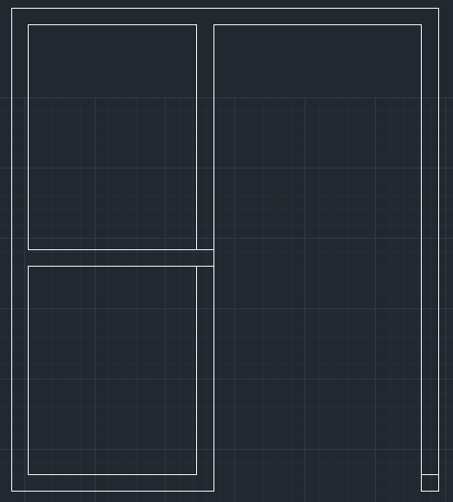

trim:

Command: _trim

Current settings: Projection=UCS, Edge=None, Mode=Quick

Select object to trim or shift-select to extend or

[cuTting edges/Crossing/mOde/Project/eRase]:

Washroom:

Command:

Command: _offset

Current settings: Erase source=No Layer=Source OFFSETGAPTYPE=0

Specify offset distance or [Through/Erase/Layer] <Through>: T

Select object to offset or [Exit/Undo] <Exit>:

Specify through point or [Exit/Multiple/Undo] <Exit>: 1000

Select object to offset or [Exit/Undo] <Exit>:

Specify through point or [Exit/Multiple/Undo] <Exit>: 150

Select object to offset or [Exit/Undo] <Exit>:

Specify through point or [Exit/Multiple/Undo] <Exit>: 1200

Select object to offset or [Exit/Undo] <Exit>:

Specify through point or [Exit/Multiple/Undo] <Exit>: 150

Select object to offset or [Exit/Undo] <Exit>:

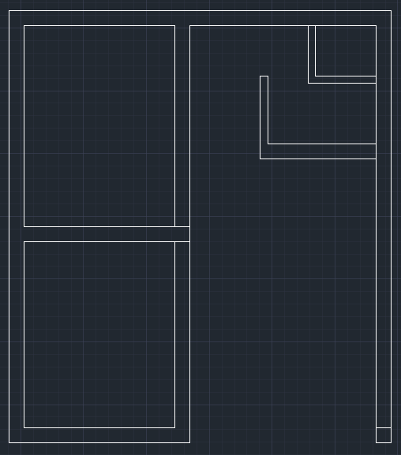

Bath:

Command: _offset

Current settings: Erase source=No Layer=Source OFFSETGAPTYPE=0

Specify offset distance or [Through/Erase/Layer] <Through>: T

Select object to offset or [Exit/Undo] <Exit>:

Specify through point or [Exit/Multiple/Undo] <Exit>: 1200

Select object to offset or [Exit/Undo] <Exit>:

Specify through point or [Exit/Multiple/Undo] <Exit>: 300

Select object to offset or [Exit/Undo] <Exit>:

Specify through point or [Exit/Multiple/Undo] <Exit>: 1250

Select object to offset or [Exit/Undo] <Exit>: _u

Select object to offset or [Exit/Undo] <Exit>:

Specify through point or [Exit/Multiple/Undo] <Exit>: 2150

Select object to offset or [Exit/Undo] <Exit>:

Specify through point or [Exit/Multiple/Undo] <Exit>: 150

Select object to offset or [Exit/Undo] <Exit>:

trim:

Command: _trim

Current settings: Projection=UCS, Edge=None, Mode=Quick

Select object to trim or shift-select to extend or

[cuTting edges/Crossing/mOde/Project/eRase]:

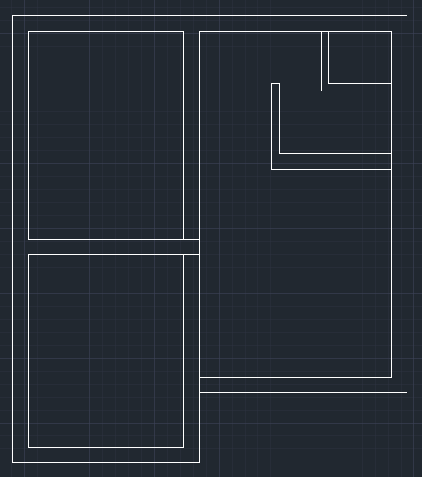

Kitchen:

Command: _offset

Current settings: Erase source=No Layer=Source OFFSETGAPTYPE=0

Specify offset distance or [Through/Erase/Layer] <Through>: T

Select object to offset or [Exit/Undo] <Exit>:

Specify through point or [Exit/Multiple/Undo] <Exit>: 4000

Select object to offset or [Exit/Undo] <Exit>:

Specify through point or [Exit/Multiple/Undo] <Exit>: 300

Select object to offset or [Exit/Undo] <Exit>: *Cancel*

Command:

Command: _trim

Current settings: Projection=UCS, Edge=None, Mode=Quick

Select object to trim or shift-select to extend or

Command: _extend

Current settings: Projection=UCS, Edge=None, Mode=Quick

Select object to extend or shift-select to trim or

Command: _trim

Current settings: Projection=UCS, Edge=None, Mode=Quick

Select object to trim or shift-select to extend or

[cuTting edges/Crossing/mOde/Project/eRase]:

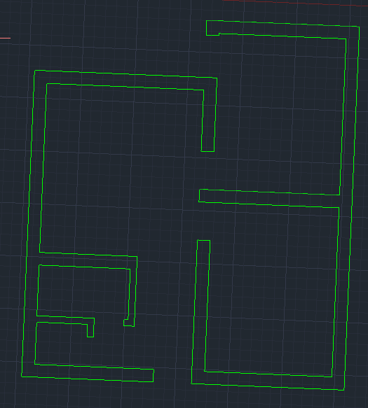

**door:**

Command: _offset

Current settings: Erase source=No Layer=Source OFFSETGAPTYPE=0

Specify offset distance or [Through/Erase/Layer] <Through>: T

Select object to offset or [Exit/Undo] <Exit>:

Specify through point or [Exit/Multiple/Undo] <Exit>: 1000

Select object to offset or [Exit/Undo] <Exit>: *Cancel*

Command: _trim

Current settings: Projection=UCS, Edge=None, Mode=Quick

Select object to trim or shift-select to extend or

[cuTting edges/Crossing/mOde/Project/eRase]:

Command: _trim

Current settings: Projection=UCS, Edge=None, Mode=Quick

Select object to trim or shift-select to extend or

[cuTting edges/Crossing/mOde/Project/eRase]:

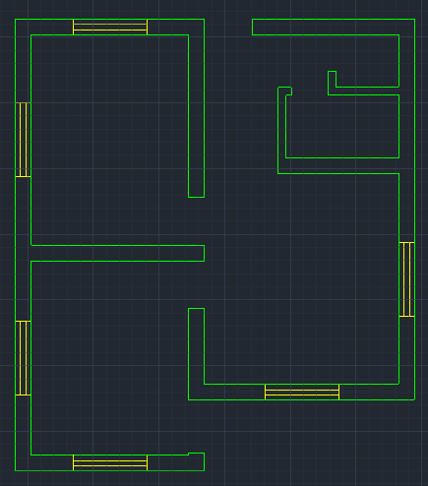

Window:

Command: _offset

Current settings: Erase source=No Layer=Source OFFSETGAPTYPE=0

Specify offset distance or [Through/Erase/Layer] <Through>: T

Select object to offset or [Exit/Undo] <Exit>:

Specify through point or [Exit/Multiple/Undo] <Exit>: 900

Select object to offset or [Exit/Undo] <Exit>:

Specify through point or [Exit/Multiple/Undo] <Exit>: 900

Select object to offset or [Exit/Undo] <Exit>: *Cancel*

Command: _trim

Current settings: Projection=UCS, Edge=None, Mode=Quick

Select object to trim or shift-select to extend or

[cuTting edges/Crossing/mOde/Project/eRase]:

Command: _offset

Current settings: Erase source=No Layer=Source OFFSETGAPTYPE=0

Specify offset distance or [Through/Erase/Layer] <Through>: T

Select object to offset or [Exit/Undo] <Exit>:

Specify through point or [Exit/Multiple/Undo] <Exit>: 900

Select object to offset or [Exit/Undo] <Exit>: *Cancel*

Command:

Command: _extend

Current settings: Projection=UCS, Edge=None, Mode=Quick

Select object to extend or shift-select to trim or

[Boundary edges/Crossing/mOde/Project]:

Command: _trim

Current settings: Projection=UCS, Edge=None, Mode=Quick

Select object to trim or shift-select to extend or

[cuTting edges/Crossing/mOde/Project/eRase]:

Command: _offset

Current settings: Erase source=No Layer=Source OFFSETGAPTYPE=0

Specify offset distance or [Through/Erase/Layer] <Through>: T

Select object to offset or [Exit/Undo] <Exit>:

Select object to offset or [Exit/Undo] <Exit>:

Specify through point or [Exit/Multiple/Undo] <Exit>: 700

Select object to offset or [Exit/Undo] <Exit>:

Specify through point or [Exit/Multiple/Undo] <Exit>: 700

Select object to offset or [Exit/Undo] <Exit>: *Cancel*

Command: _extend

Current settings: Projection=UCS, Edge=None, Mode=Quick

Select object to extend or shift-select to trim or

[Boundary edges/Crossing/mOde/Project]:

Command: _extend

Current settings: Projection=UCS, Edge=None, Mode=Quick

Select object to extend or shift-select to trim or

[Boundary edges/Crossing/mOde/Project]:

]:

3D Start:

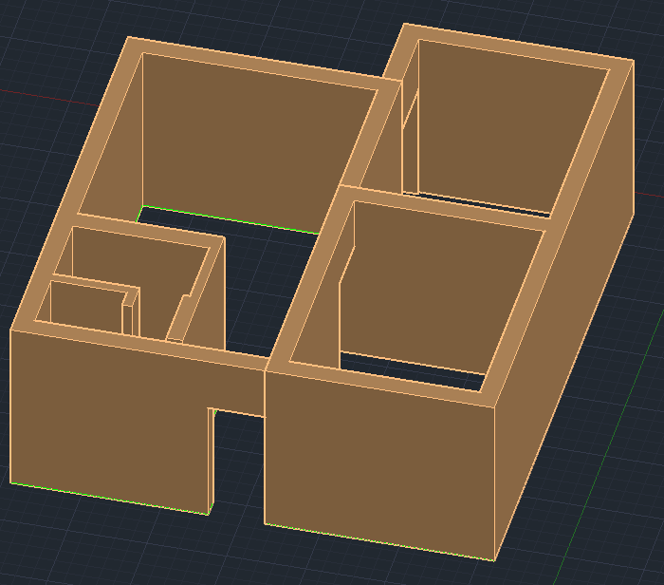

Command: _presspull

Select object or bounded area:

Specify extrusion height or [Multiple]:

Specify extrusion height or [Multiple]:M

Select bounded area:

1 selected, 2 total

Select bounded area:

Specify extrusion height or [Multiple]:

Specify extrusion height or [Multiple]:3000

2 extrusion(s) created

Command: _solidedit

Solids editing automatic checking: SOLIDCHECK=1

Enter a solids editing option [Face/Edge/Body/Undo/eXit] <eXit>: _edge

Resuming SOLIDEDIT command.

Select edges or [Undo/Remove]:

Select edges or [Undo/Remove]:

Specify a base point or displacement: 900

Specify a second point of displacement: 900

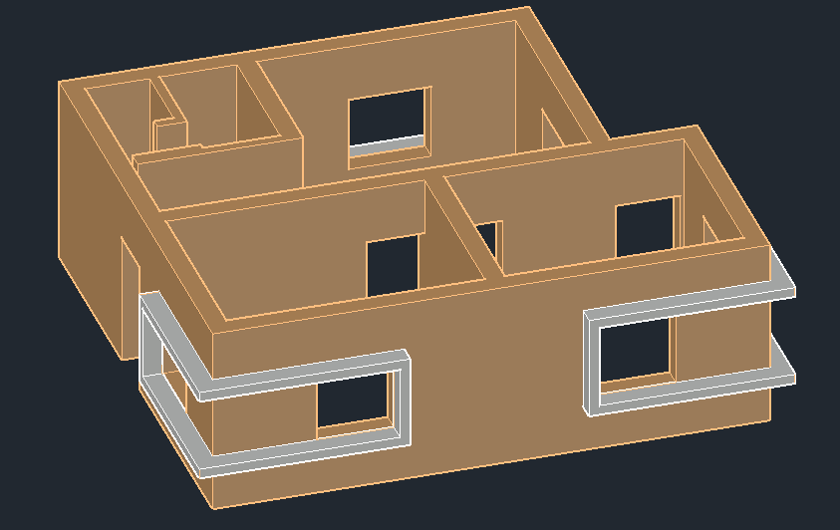

Command: _presspull

Select object or bounded area:

Click a face, curve, or inside a bounded area

Select object or bounded area:

Click a face, curve, or inside a bounded area

Select object or bounded area:

Specify extrusion height or [Multiple]:

Specify extrusion height or [Multiple]:M

Select bounded area:

Resuming PRESSPULL command.

Select bounded area:

Select bounded area:

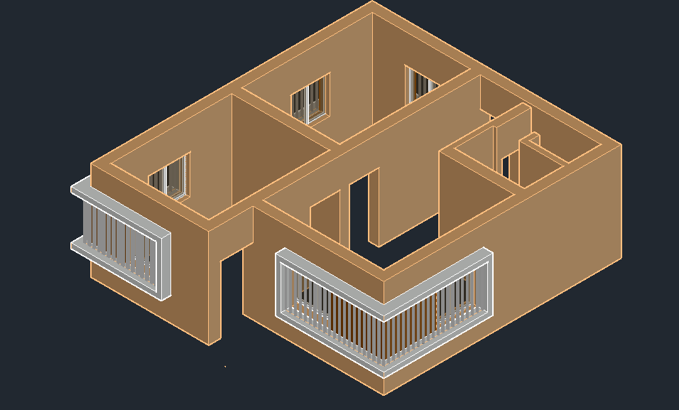

1 loop extracted.

1 Region created.

1 selected, 2 total

Select bounded area:

Resuming PRESSPULL command.

Select bounded area:

1 loop extracted.

1 Region created.

1 selected, 3 total

Select bounded area:

Resuming PRESSPULL command.

Select bounded area:

1 loop extracted.

1 Region created.

1 selected, 4 total

Select bounded area:

Resuming PRESSPULL command.

Select bounded area:

1 loop extracted.

1 Region created.

1 selected, 5 total

Select bounded area:

Specify extrusion height or [Multiple]:

Specify extrusion height or [Multiple]:900

Windows

Command: _rectang

Specify first corner point or [Chamfer/Elevation/Fillet/Thickness/Width]: 900

Specify other corner point or [Area/Dimensions/Rotation]: 1200

Command: _copy

Select objects: 1 found

Select objects: l

1 found (1 duplicate), 1 total

Select objects:

Current settings: Copy mode = Multiple

Command: _presspull

Select object or bounded area:

Specify extrusion height or [Multiple]:

Specify extrusion height or [Multiple]:300

1 extrusion(s) created

Command: _move

Select objects: 1 found

Select objects: 1 found, 2 total

Command: _presspull

Select object or bounded area:

Specify extrusion height or [Multiple]:

Specify extrusion height or [Multiple]:300

1 extrusion(s) created

Select object or bounded area:

Specify extrusion height or [Multiple]:

Specify extrusion height or [Multiple]:300

1 extrusion(s) created

Command: _presspull

Select object or bounded area:

Click a face, curve, or inside a bounded area

Select object or bounded area:

Click a face, curve, or inside a bounded area

Select object or bounded area:

Click a face, curve, or inside a bounded area

Select object or bounded area:

Specify extrusion height or [Multiple]:

Specify extrusion height or [Multiple]:M

Select bounded area:

1 selected, 2 total

Select bounded area:

1 selected, 3 total

Select bounded area:

1 selected, 4 total

Command: _union

Select objects: 1 found

Select objects: 1 found, 2 total

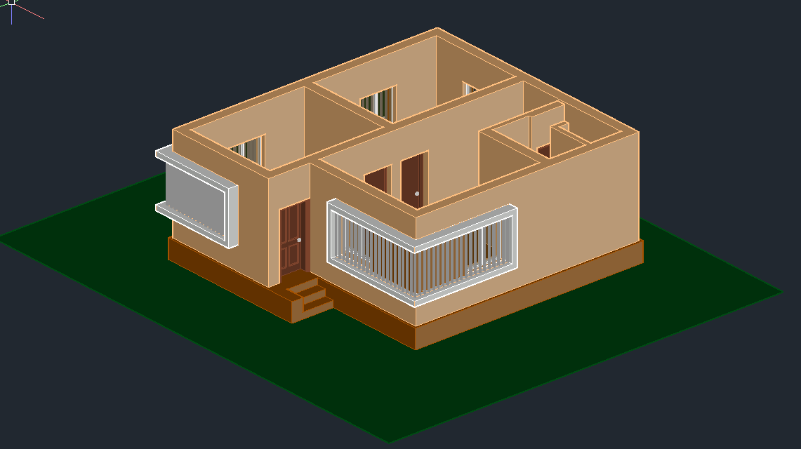

Command: _imprint

Select a 3D solid or surface:

Select an object to imprint:

Delete the source object [Yes/No] <N>:

Select an object to imprint:

Resuming IMPRINT command.

Select an object to imprint:

Delete the source object [Yes/No] <N>:

Select an object to imprint:

Resuming IMPRINT command.

Select an object to imprint:

Delete the source object [Yes/No] <N>:

Select an object to imprint:

Command: _solidedit

Solids editing automatic checking: SOLIDCHECK=1

Enter a solids editing option [Face/Edge/Body/Undo/eXit] <eXit>: _face

Enter a face editing option

[Extrude/Move/Rotate/Offset/Taper/Delete/Copy/coLor/mAterial/Undo/eXit] <eXit>: _color

Select faces or [Undo/Remove]: 1 face found.

Select faces or [Undo/Remove/ALL]:

Resuming SOLIDEDIT command.

Select faces or [Undo/Remove/ALL]:

Resuming SOLIDEDIT command.

Select faces or [Undo/Remove/ALL]: 1 face found.

Select faces or [Undo/Remove/ALL]:

PLANIT

Command: _offset

Current settings: Erase source=No Layer=Source OFFSETGAPTYPE=0

Specify offset distance or [Through/Erase/Layer] <Through>: *Cancel*

Command:

Command: _offset

Current settings: Erase source=No Layer=Source OFFSETGAPTYPE=0

Specify offset distance or [Through/Erase/Layer] <Through>: 75

Select object to offset or [Exit/Undo] <Exit>: *Cancel*

Command:

Command:

Command: _offset

Current settings: Erase source=No Layer=Source OFFSETGAPTYPE=0

Specify offset distance or [Through/Erase/Layer] <75.0000>:

Select object to offset or [Exit/Undo] <Exit>:

Specify point on side to offset or [Exit/Multiple/Undo] <Exit>:

Select object to offset or [Exit/Undo] <Exit>:

Specify point on side to offset or [Exit/Multiple/Undo] <Exit>:

Select object to offset or [Exit/Undo] <Exit>: *Cancel*

Command: PEDIT

Select polyline or [Multiple]:

Enter an option [Close/Join/Width/Edit vertex/Fit/Spline/Decurve/Ltype gen/Reverse/Undo]: *Cancel*

Command:

Command:

Command: PEDIT

Select polyline or [Multiple]: *Cancel*

Command: _OPEN

Command: _qsave

Window Lasso Press Spacebar to cycle options

Command: _fillet

Current settings: Mode = TRIM, Radius = 0.0000

Select first object or [Undo/Polyline/Radius/Trim/Multiple]:

Select second object or shift-select to apply corner or [Radius]:

Command: PEDIT

Select polyline or [Multiple]:

Enter an option [Close/Join/Width/Edit vertex/Fit/Spline/Decurve/Ltype gen/Reverse/Undo]: C

Enter an option [Open/Join/Width/Edit vertex/Fit/Spline/Decurve/Ltype gen/Reverse/Undo]:

Command: '_.-LAYER

Current layer: "Plinth"

Enter an option [?/Make/Set/New/Rename/ON/OFF/Color/Ltype/LWeight/TRansparency/MATerial/Plot/Freeze/Thaw/LOck/Unlock/stAte/Description/rEconcile/Xref]: _COLOR

New color [Truecolor/COlorbook] : 160

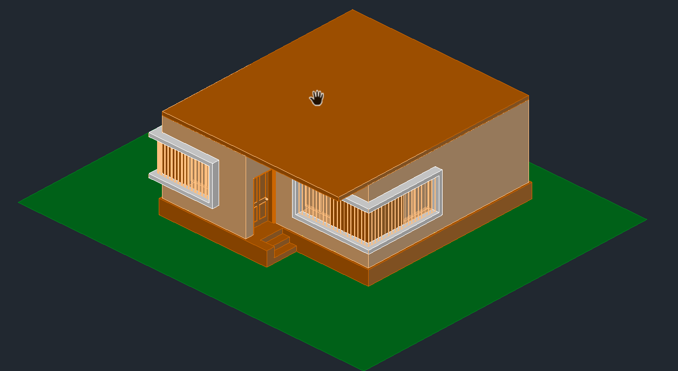

Enter name list of layer(s) for color 160 <Plinth>: =Plinth

Enter an option [?/Make/Set/New/Rename/ON/OFF/Color/Ltype/LWeight/TRansparency/MATerial/Plot/Freeze/Thaw/LOck/Unlock/stAte/Description/rEconcile/Xref]:

Command:

Command:

Command:

Command: _pedit

Enter an option [Open/Join/Width/Edit vertex/Fit/Spline/Decurve/Ltype gen/Reverse/Undo]: *Cancel*

Command: *Cancel*

Command:

Command:

Command:

Command:

Command: _pedit

Enter an option [Open/Join/Width/Edit vertex/Fit/Spline/Decurve/Ltype gen/Reverse/Undo]: *Cancel*

Command:

Command: *Cancel*

Command:

Command: '_.-LAYER

Current layer: "Plinth"

Enter an option [?/Make/Set/New/Rename/ON/OFF/Color/Ltype/LWeight/TRansparency/MATerial/Plot/Freeze/Thaw/LOck/Unlock/stAte/Description/rEconcile/Xref]: _OFF

Enter name list of layer(s) to turn off or <select objects>: =0

Enter an option [?/Make/Set/New/Rename/ON/OFF/Color/Ltype/LWeight/TRansparency/MATerial/Plot/Freeze/Thaw/LOck/Unlock/stAte/Description/rEconcile/Xref]:

Command:

Command: '_.-LAYER

Current layer: "Plinth"

Enter an option [?/Make/Set/New/Rename/ON/OFF/Color/Ltype/LWeight/TRansparency/MATerial/Plot/Freeze/Thaw/LOck/Unlock/stAte/Description/rEconcile/Xref]: _ON

Enter name list of layer(s) to turn on: =0

Enter an option [?/Make/Set/New/Rename/ON/OFF/Color/Ltype/LWeight/TRansparency/MATerial/Plot/Freeze/Thaw/LOck/Unlock/stAte/Description/rEconcile/Xref]:

Command:

Command: '_.-LAYER

Current layer: "Plinth"

Enter an option [?/Make/Set/New/Rename/ON/OFF/Color/Ltype/LWeight/TRansparency/MATerial/Plot/Freeze/Thaw/LOck/Unlock/stAte/Description/rEconcile/Xref]: _ON

Enter name list of layer(s) to turn on: =3D Wall

Enter an option [?/Make/Set/New/Rename/ON/OFF/Color/Ltype/LWeight/TRansparency/MATerial/Plot/Freeze/Thaw/LOck/Unlock/stAte/Description/rEconcile/Xref]:

Crossing Lasso Press Spacebar to cycle options

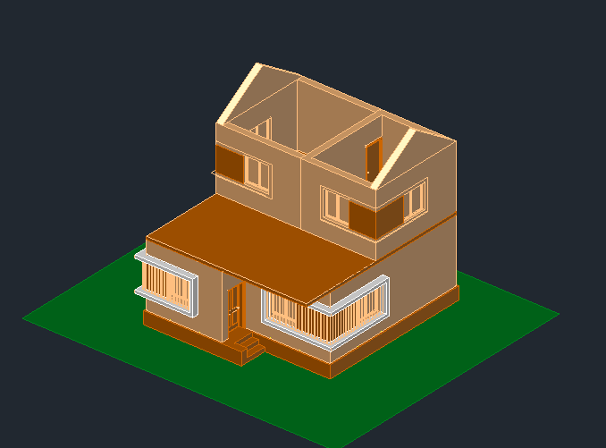

Command: _extrude

Current wire frame density: ISOLINES=4, Closed profiles creation mode = Solid

1 found

_MO Closed profiles creation mode [SOlid/SUrface] <Solid>: _SO

Specify height of extrusion or [Direction/Path/Taper angle/Expression]: *Cancel*

Command:

Command: '_.-LAYER

Current layer: "Plinth"

Enter an option [?/Make/Set/New/Rename/ON/OFF/Color/Ltype/LWeight/TRansparency/MATerial/Plot/Freeze/Thaw/LOck/Unlock/stAte/Description/rEconcile/Xref]: _OFF

Enter name list of layer(s) to turn off or <select objects>: =Plinth

Really want layer "Plinth" (the CURRENT layer) off? <N> _Yes

Enter an option [?/Make/Set/New/Rename/ON/OFF/Color/Ltype/LWeight/TRansparency/MATerial/Plot/Freeze/Thaw/LOck/Unlock/stAte/Description/rEconcile/Xref]:

Command: _extrude

Current wire frame density: ISOLINES=4, Closed profiles creation mode = Solid

1 found

_MO Closed profiles creation mode [SOlid/SUrface] <Solid>: _SO

Specify height of extrusion or [Direction/Path/Taper angle/Expression]: 600

Command: Specify opposite corner or [Fence/WPolygon/CPolygon]: *Cancel*

Command:

LAYER

Command: Specify opposite corner or [Fence/WPolygon/CPolygon]:

Command: Specify opposite corner or [Fence/WPolygon/CPolygon]:

Invalid window specification.

Specify opposite corner or [Fence/WPolygon/CPolygon]: Specify opposite corner or [Fence/WPolygon/CPolygon]:

Command: '_.-LAYER

Current layer: "Plinth"

Enter an option [?/Make/Set/New/Rename/ON/OFF/Color/Ltype/LWeight/TRansparency/MATerial/Plot/Freeze/Thaw/LOck/Unlock/stAte/Description/rEconcile/Xref]: _OFF

Enter name list of layer(s) to turn off or <select objects>: =0

Enter an option [?/Make/Set/New/Rename/ON/OFF/Color/Ltype/LWeight/TRansparency/MATerial/Plot/Freeze/Thaw/LOck/Unlock/stAte/Description/rEconcile/Xref]:

Command:

Command: '_.-LAYER

Current layer: "Plinth"

Enter an option [?/Make/Set/New/Rename/ON/OFF/Color/Ltype/LWeight/TRansparency/MATerial/Plot/Freeze/Thaw/LOck/Unlock/stAte/Description/rEconcile/Xref]: _LOCK

Enter name list of layer(s) to lock or <select objects>: =3D Wall

Enter an option [?/Make/Set/New/Rename/ON/OFF/Color/Ltype/LWeight/TRansparency/MATerial/Plot/Freeze/Thaw/LOck/Unlock/stAte/Description/rEconcile/Xref]:

Command: _u '.-LAYER '.-LAYER

Command: _presspull

Select object or bounded area:

Specify extrusion height or [Multiple]:

Specify extrusion height or [Multiple]:900

1 extrusion(s) created

Select object or bounded area:

Command: _solidedit

Solids editing automatic checking: SOLIDCHECK=1

Enter a solids editing option [Face/Edge/Body/Undo/eXit] <eXit>: _edge

Enter an edge editing option [Copy/coLor/Undo/eXit] <eXit>: _copy

Select edges or [Undo/Remove]:

Select edges or [Undo/Remove]:

Specify a base point or displacement:

Specify a second point of displacement: 1000

Enter an edge editing option [Copy/coLor/Undo/eXit] <eXit>: C

Select edges or [Undo/Remove]:

Select edges or [Undo/Remove]:

Specify a base point or displacement:

Specify a second point of displacement: 200

Enter an edge editing option [Copy/coLor/Undo/eXit] <eXit>: C

Select edges or [Undo/Remove]:

Select edges or [Undo/Remove]:

Select edges or [Undo/Remove]:

Specify a base point or displacement:

Specify a second point of displacement: <Ortho on> 200

Enter an edge editing option [Copy/coLor/Undo/eXit] <eXit>: *Cancel*

Command: _presspull

Select object or bounded area:

Command: _qsave

Command: _presspull

Select object or bounded area:

Specify extrusion height or [Multiple]:

Specify extrusion height or [Multiple]:300

1 extrusion(s) created

Select object or bounded area:

Specify extrusion height or [Multiple]:

Specify extrusion height or [Multiple]:600

1 extrusion(s) created

Select object or bounded area:

Resuming PRESSPULL command.

Select object or bounded area:

Resuming PRESSPULL command.

Select object or bounded area:

Command: Specify opposite corner or [Fence/WPolygon/CPolygon]:

Command: Specify opposite corner or [Fence/WPolygon/CPolygon]:

Command: _.erase 3 found

Command: MAT

MATBROWSEROPEN

MATBROWSEROPEN

Command: _u DROPGEOM GROUP

Command: _u INTELLIZOOM INTELLIZOOM '.3DPAN2

Command: Specify opposite corner or [Fence/WPolygon/CPolygon]:

Command: Specify opposite corner or [Fence/WPolygon/CPolygon]: *Cancel*

Command: _.erase 1 found

Command: '_.-LAYER

Current layer: "Plinth"

Enter an option [?/Make/Set/New/Rename/ON/OFF/Color/Ltype/LWeight/TRansparency/MATerial/Plot/Freeze/Thaw/LOck/Unlock/stAte/Description/rEconcile/Xref]: _OFF

Enter name list of layer(s) to turn off or <select objects>: =3D Wall

Enter an option [?/Make/Set/New/Rename/ON/OFF/Color/Ltype/LWeight/TRansparency/MATerial/Plot/Freeze/Thaw/LOck/Unlock/stAte/Description/rEconcile/Xref]:

Command:

Command: '_.-LAYER

Current layer: "Plinth"

Enter an option [?/Make/Set/New/Rename/ON/OFF/Color/Ltype/LWeight/TRansparency/MATerial/Plot/Freeze/Thaw/LOck/Unlock/stAte/Description/rEconcile/Xref]: _ON

Enter name list of layer(s) to turn on: =3D Wall

Enter an option [?/Make/Set/New/Rename/ON/OFF/Color/Ltype/LWeight/TRansparency/MATerial/Plot/Freeze/Thaw/LOck/Unlock/stAte/Description/rEconcile/Xref]:

Command:

Command: '_.-LAYER

Current layer: "Plinth"

Enter an option [?/Make/Set/New/Rename/ON/OFF/Color/Ltype/LWeight/TRansparency/MATerial/Plot/Freeze/Thaw/LOck/Unlock/stAte/Description/rEconcile/Xref]: _OFF

Enter name list of layer(s) to turn off or <select objects>: =0

Enter an option [?/Make/Set/New/Rename/ON/OFF/Color/Ltype/LWeight/TRansparency/MATerial/Plot/Freeze/Thaw/LOck/Unlock/stAte/Description/rEconcile/Xref]:

Command: _rectang

Specify first corner point or [Chamfer/Elevation/Fillet/Thickness/Width]:

Specify other corner point or [Area/Dimensions/Rotation]

DOOR

Command: _trim

View is not plan to UCS. Command results may not be obvious.

Current settings: Projection=UCS, Edge=None, Mode=Quick

Select object to trim or shift-select to extend or

[cuTting edges/Crossing/mOde/Project/eRase]:

Edge is perpendicular to UCS XY plane.

Select object to trim or shift-select to extend or

[cuTting edges/Crossing/mOde/Project/eRase/Undo]:

Edge is perpendicular to UCS XY plane.

Select object to trim or shift-select to extend or

[cuTting edges/Crossing/mOde/Project/eRase/Undo]: *Cancel*

Command:

Command: _trim

View is not plan to UCS. Command results may not be obvious.

Current settings: Projection=UCS, Edge=None, Mode=Quick

Select object to trim or shift-select to extend or

[cuTting edges/Crossing/mOde/Project/eRase]:

Select object to trim or shift-select to extend or

[cuTting edges/Crossing/mOde/Project/eRase/Undo]: *Cancel*

Command:

Command: _pline

Specify start point: *Cancel*

Command:

Command: _pline

Specify start point: *Cancel*

Command:

Command:

Command: _pline

Specify start point:

Current line-width is 0.0000

Specify next point or [Arc/Halfwidth/Length/Undo/Width]: 50

Specify next point or [Arc/Close/Halfwidth/Length/Undo/Width]: 30

Specify next point or [Arc/Close/Halfwidth/Length/Undo/Width]: 20

Specify next point or [Arc/Close/Halfwidth/Length/Undo/Width]: 270

Specify next point or [Arc/Close/Halfwidth/Length/Undo/Width]:

Specify next point or [Arc/Close/Halfwidth/Length/Undo/Width]:

Specify next point or [Arc/Close/Halfwidth/Length/Undo/Width]: *Cancel*

Automatic save to C:\Users\Abdullah\AppData\Local\Temp\ED project_1_4713_b5ee4250.sv$ ...

Command: _chamfer

(TRIM mode) Current chamfer Dist1 = 0.0000, Dist2 = 0.0000

Select first line or [Undo/Polyline/Distance/Angle/Trim/mEthod/Multiple]:

Select second line or shift-select to apply corner or [Distance/Angle/Method]: D

Specify first chamfer distance <0.0000>: 70

Specify second chamfer distance <70.0000>:

Select second line or shift-select to apply corner or [Distance/Angle/Method]:

Command: _ellipse

Specify axis endpoint of ellipse or [Arc/Center]: _c

Specify center of ellipse: *Cancel*

Command: _ellipse

Specify axis endpoint of ellipse or [Arc/Center]: _c

Specify center of ellipse:

Specify endpoint of axis: 20

Specify distance to other axis or [Rotation]: 20

Automatic save to C:\Users\Abdullah\AppData\Local\Temp\ED project_1_4713_b5ee4250.sv$ ...

Command:

Command: _u ELLIPSE GROUP

Command:

Command:

Command: _circle

Specify center point for circle or [3P/2P/Ttr (tan tan radius)]:

Specify radius of circle or [Diameter]: 20

Command:

Command:

Command:

Command: _circle

Specify center point for circle or [3P/2P/Ttr (tan tan radius)]: _ttr

Specify point on object for first tangent of circle:

Specify point on object for second tangent of circle:

Specify radius of circle <20.0000>: 15

Command:

Command:

Command: _circle

Specify center point for circle or [3P/2P/Ttr (tan tan radius)]: _ttr

Specify point on object for first tangent of circle:

Specify point on object for second tangent of circle:

Specify radius of circle <15.0000>:

Command: _sweep

Current wire frame density: ISOLINES=4, Closed profiles creation mode = Solid

Select objects to sweep or [MOde]: _MO Closed profiles creation mode [SOlid/SUrface] <Solid>: _SO

Select objects to sweep or [MOde]: 1 found

Select objects to sweep or [MOde]: 1 found, 2 total

Select objects to sweep or [MOde]:

Select sweep path or [Alignment/Base point/Scale/Twist]:

Profile curve may not be selected as path curve.

Select sweep path or [Alignment/Base point/Scale/Twist]: *Cancel*

Command: *Cancel*

Command:

Command:

Command: _sweep

Current wire frame density: ISOLINES=4, Closed profiles creation mode = Solid

Select objects to sweep or [MOde]: _MO Closed profiles creation mode [SOlid/SUrface] <Solid>: _SO

Select objects to sweep or [MOde]: 1 found

Select objects to sweep or [MOde]:

Select sweep path or [Alignment/Base point/Scale/Twist]:

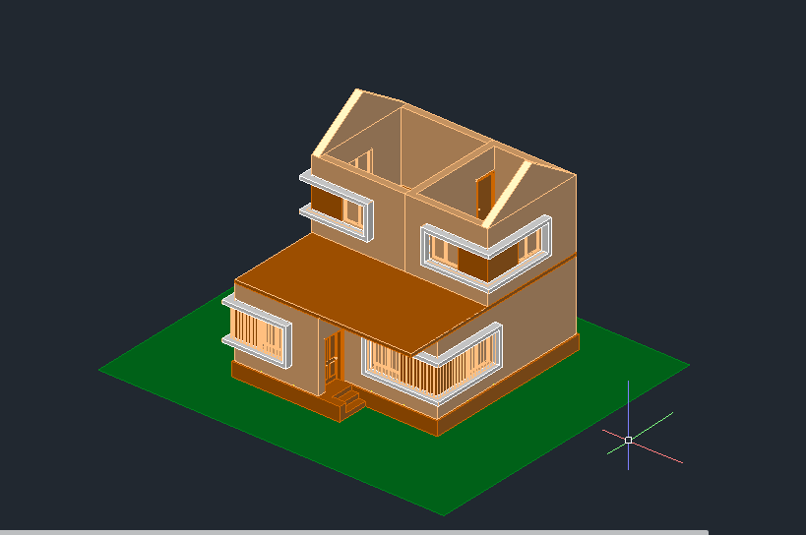

QUICKPROPERTIES

Command: *Cancel*

Window Lasso Press Spacebar to cycle options

Command: _rectang

Specify first corner point or [Chamfer/Elevation/Fillet/Thickness/Width]:

Specify other corner point or [Area/Dimensions/Rotation]: *Cancel*

Command: _rectang

Specify first corner point or [Chamfer/Elevation/Fillet/Thickness/Width]:

Specify other corner point or [Area/Dimensions/Rotation]:

Resuming RECTANG command.

Specify other corner point or [Area/Dimensions/Rotation]:

Resuming RECTANG command.

Specify other corner point or [Area/Dimensions/Rotation]:

>>Enter new value for ORTHOMODE <0>:

Resuming RECTANG command.

Specify other corner point or [Area/Dimensions/Rotation]:

Resuming RECTANG command.

Specify other corner point or [Area/Dimensions/Rotation]:

Command:

Command: _u INTELLIZOOM GROUP menu item

Command: _u INTELLIZOOM

Command: _u RECTANG GROUP

Command:

Command:

Command: _rectang

Specify first corner point or [Chamfer/Elevation/Fillet/Thickness/Width]: *Cancel*

Command:

Command: _rectang

Specify first corner point or [Chamfer/Elevation/Fillet/Thickness/Width]:

Specify other corner point or [Area/Dimensions/Rotation]:

Resuming RECTANG command.

Specify other corner point or [Area/Dimensions/Rotation]:

Resuming RECTANG command.

Specify other corner point or [Area/Dimensions/Rotation]:

Resuming RECTANG command.

Specify other corner point or [Area/Dimensions/Rotation]:

Resuming RECTANG command.

Specify other corner point or [Area/Dimensions/Rotation]:

Resuming RECTANG command.

Specify other corner point or [Area/Dimensions/Rotation]:

Resuming RECTANG command.

Specify other corner point or [Area/Dimensions/Rotation]:

Resuming RECTANG command.

Specify other corner point or [Area/Dimensions/Rotation]:

Command: _move

Select objects: 1 found

Select objects:

Specify base point or [Displacement] <Displacement>:

Specify second point or <use first point as displacement>:

Resuming MOVE command.

Specify second point or <use first point as displacement>:

Resuming MOVE command.

Specify second point or <use first point as displacement>:

Automatic save to C:\Users\Abdullah\AppData\Local\Temp\ED project_1_17377_ed41334a.sv$ ...

Command: _offset

Current settings: Erase source=No Layer=Source OFFSETGAPTYPE=0

Specify offset distance or [Through/Erase/Layer] <75.0000>: 100

Select object to offset or [Exit/Undo] <Exit>:

Specify point on side to offset or [Exit/Multiple/Undo] <Exit>:

Select object to offset or [Exit/Undo] <Exit>: *Cancel*

Command: X

EXPLODE

Select objects: 1 found

Select objects:

Command:

Command:

Command: _offset

Current settings: Erase source=No Layer=Source OFFSETGAPTYPE=0

Specify offset distance or [Through/Erase/Layer] <100.0000>: 200

Select object to offset or [Exit/Undo] <Exit>:

Specify point on side to offset or [Exit/Multiple/Undo] <Exit>:

Select object to offset or [Exit/Undo] <Exit>:

Specify point on side to offset or [Exit/Multiple/Undo] <Exit>: 1100

Select object to offset or [Exit/Undo] <Exit>:

Specify point on side to offset or [Exit/Multiple/Undo] <Exit>: 150

Select object to offset or [Exit/Undo] <Exit>: *Cancel*

Command:

Command:

Command:

Command: _line

Specify first point:

Specify next point or [Undo]:

Specify next point or [Undo]: *Cancel*

Command:

Command:

Command: _offset

Current settings: Erase source=No Layer=Source OFFSETGAPTYPE=0

Specify offset distance or [Through/Erase/Layer] <Through>: 50

Select object to offset or [Exit/Undo] <Exit>:

Specify point on side to offset or [Exit/Multiple/Undo] <Exit>:

Select object to offset or [Exit/Undo] <Exit>:

Specify point on side to offset or [Exit/Multiple/Undo] <Exit>:

Command: _move

Select objects: 1 found

Select objects: 1 found, 2 total

Select objects:

Specify base point or [Displacement] <Displacement>:

Specify second point or <use first point as displacement>: 5

Command:

Command:

Command: _loft

Current wire frame density: ISOLINES=4, Closed profiles creation mode = Solid

Select cross sections in lofting order or [POint/Join multiple edges/MOde]: _MO Closed profiles creation mode [SOlid/SUrface] <Solid>: _SO

Select cross sections in lofting order or [POint/Join multiple edges/MOde]: 1 found

Select cross sections in lofting order or [POint/Join multiple edges/MOde]: 1 found, 2 total

Select cross sections in lofting order or [POint/Join multiple edges/MOde]:

2 cross sections selected

Enter an option [Guides/Path/Cross sections only/Settings] <Cross sections only>: C

Command:

Command:

Command: _loft

Current wire frame density: ISOLINES=4, Closed profiles creation mode = Solid

Select cross sections in lofting order or [POint/Join multiple edges/MOde]: _MO Closed profiles creation mode [SOlid/SUrface] <Solid>: _SO

Select cross sections in lofting order or [POint/Join multiple edges/MOde]: 1 found

Select cross sections in lofting order or [POint/Join multiple edges/MOde]: 1 found, 2 total

Select cross sections in lofting order or [POint/Join multiple edges/MOde]:

2 cross sections selected

Enter an option [Guides/Path/Cross sections only/Settings] <Cross sections only>: C

Command: Specify opposite corner or [Fence/WPolygon/CPolygon]: *Cancel*

Command:

Automatic save to C:\Users\Abdullah\AppData\Local\Temp\ED project_1_16897_9d8fcab8.sv$ ...

Command:

Command:

Command:

Command:

Command: _join

Select source object or multiple objects to join at once: Specify opposite corner: 0 found

Select source object or multiple objects to join at once: Specify opposite corner: 2 found

Select objects to join:

2 objects converted to 1 polyline

Command: _u JOIN GROUP

Command: _u '.3DPAN2

Command:

Command:

Command:

Command:

Command: _join

Select source object or multiple objects to join at once: 1 found

Select objects to join: 1 found, 2 total

Select objects to join: 1 found, 3 total

Select objects to join: 1 found, 4 total

Select objects to join:

4 objects converted to 1 polyline

Command:

Command:

Command: _extrude

Current wire frame density: ISOLINES=4, Closed profiles creation mode = Solid

Select objects to extrude or [MOde]: _MO Closed profiles creation mode [SOlid/SUrface] <Solid>: _SO

Select objects to extrude or [MOde]: 1 found

Select objects to extrude or [MOde]: Specify opposite corner: 1 found (1 duplicate), 1 total

Select objects to extrude or [MOde]:

Specify height of extrusion or [Direction/Path/Taper angle/Expression] <-600.0000>: 30

Command:

Command:

Command: _presspull

Select object or bounded area:

Specify extrusion height or [Multiple]:

Specify extrusion height or [Multiple]:M

Select bounded area:

1 selected, 2 total

Select bounded area:

1 selected, 3 total

Select bounded area:

1 selected, 4 total

Select bounded area:

Specify extrusion height or [Multiple]:

Specify extrusion height or [Multiple]:5

4 extrusion(s) created

Command: _move

Select objects: 1 found

Select objects: *Cancel*

Command:

Command: _copy

Select objects: 1 found

Select objects:

Current settings: Copy mode = Multiple

Specify base point or [Displacement/mOde] <Displacement>:

Too many objects selected for INTERSECT

Specify second point or [Array] <use first point as displacement>:

Resuming COPY command.

Specify second point or [Array] <use first point as displacement>: <Ortho off>

Specify second point or [Array/Exit/Undo] <Exit>: *Cancel*

Command:

Command:

Window Lasso Press Spacebar to cycle options

Command:

Command:

Command:

Command: _copy

Select objects: *Cancel*

Command:

Command: _copy

Select objects: 1 found

Select objects:

Resuming COPY command.

Select objects:

Current settings: Copy mode = Multiple

Specify base point or [Displacement/mOde] <Displacement>:

Too many objects selected for INTERSECT

Specify second point or [Array] <use first point as displacement>:

Resuming COPY command.

Specify second point or [Array] <use first point as displacement>:

Resuming COPY command.

Specify second point or [Array] <use first point as displacement>:

Resuming COPY command.

Specify second point or [Array] <use first point as displacement>:

Resuming COPY command.

Specify second point or [Array] <use first point as displacement>:

Specify second point or [Array/Exit/Undo] <Exit>: *Cancel*

Command: _move 1 found

Specify base point or [Displacement] <Displacement>:

Specify second point or <use first point as displacement>: <Ortho on>

Command: P

PAN

Command:

Command:

Command:

Command: _move 1 found

Specify base point or [Displacement] <Displacement>:

Specify second point or <use first point as displacement>:

Command: *Cancel*

Command:

Command:

Command:

Command:

Command: _move 1 found

Specify base point or [Displacement] <Displacement>:

Specify second point or <use first point as displacement>:

Command: *Cancel*

Automatic save to C:\Users\Abdullah\AppData\Local\Temp\ED project_1_14969_40ec7ac9.sv$ ...

Command: _copy

Select objects: Specify opposite corner: 3 found

Select objects:

Current settings: Copy mode = Multiple

Specify base point or [Displacement/mOde] <Displacement>:

Specify second point or [Array] <use first point as displacement>:

Resuming COPY command.

Specify second point or [Array] <use first point as displacement>:

Resuming COPY command.

Specify second point or [Array] <use first point as displacement>:

Resuming COPY command.

Specify second point or [Array] <use first point as displacement>:

Resuming COPY command.

Specify second point or [Array] <use first point as displacement>:

Specify second point or [Array/Exit/Undo] <Exit>: *Cancel*

Command: _copy 1 found

Current settings: Copy mode = Multiple

Specify base point or [Displacement/mOde] <Displacement>:

Checking 861 intersections...

Specify second point or [Array] <use first point as displacement>: <Ortho off>

Resuming COPY command.

Specify second point or [Array] <use first point as displacement>:

Resuming COPY command.

Specify second point or [Array] <use first point as displacement>:

Resuming COPY command.

Specify second point or [Array] <use first point as displacement>:

Checking 780 intersections...

Specify second point or [Array/Exit/Undo] <Exit>: *Cancel*

Command: _move 1 found

Specify base point or [Displacement] <Displacement>:

Resuming MOVE command.

Specify base point or [Displacement] <Displacement>:

Specify second point or <use first point as displacement>:

Command:

Command: _.erase 1 found

Command: _copy

Select objects: Specify opposite corner: 3 found

Select objects:

Current settings: Copy mode = Multiple

Specify base point or [Displacement/mOde] <Displacement>:

Specify second point or [Array] <use first point as displacement>: <Ortho on>

Resuming COPY command.

Specify second point or [Array] <use first point as displacement>:

Specify second point or [Array/Exit/Undo] <Exit>: *Cancel*

Command: _3drotate

Current positive angle in UCS: ANGDIR=counterclockwise ANGBASE=0

Select objects: Specify opposite corner: 3 found

Select objects:

Specify base point:

** ROTATE **

Specify rotation angle or [Base point/Copy/Undo/Reference/eXit]:

Command: _3drotate

Current positive angle in UCS: ANGDIR=counterclockwise ANGBASE=0

Select objects: Specify opposite corner: 3 found

Select objects:

Specify base point:

** ROTATE **

Specify rotation angle or [Base point/Copy/Undo/Reference/eXit]:

Command:

3DROTATE

Current positive angle in UCS: ANGDIR=counterclockwise ANGBASE=0

3 found

Specify base point: *Cancel*

Command: _move

Select objects: Specify opposite corner: 3 found

Select objects:

Resuming MOVE command.

Select objects:

Specify base point or [Displacement] <Displacement>:

Specify second point or <use first point as displacement>: <Ortho off>

Resuming MOVE command.

Specify second point or <use first point as displacement>:

Resuming MOVE command.

Specify second point or <use first point as displacement>:

Resuming MOVE command.

Specify second point or <use first point as displacement>:

Command: MOVE

Select objects: *Cancel*

Command: _solidedit

Solids editing automatic checking: SOLIDCHECK=1

Enter a solids editing option [Face/Edge/Body/Undo/eXit] <eXit>: _face

Enter a face editing option

[Extrude/Move/Rotate/Offset/Taper/Delete/Copy/coLor/mAterial/Undo/eXit] <eXit>: _move

Select faces or [Undo/Remove]: 1 face found.

Select faces or [Undo/Remove/ALL]:

Resuming SOLIDEDIT command.

Select faces or [Undo/Remove/ALL]:

Resuming SOLIDEDIT command.

Select faces or [Undo/Remove/ALL]:

Resuming SOLIDEDIT command.

Select faces or [Undo/Remove/ALL]:

Resuming SOLIDEDIT command.

Select faces or [Undo/Remove/ALL]:

Resuming SOLIDEDIT command.

Select faces or [Undo/Remove/ALL]:

Resuming SOLIDEDIT command.

Select faces or [Undo/Remove/ALL]:

Resuming SOLIDEDIT command.

Select faces or [Undo/Remove/ALL]: 1 face found.

Select faces or [Undo/Remove/ALL]:

Resuming SOLIDEDIT command.

Select faces or [Undo/Remove/ALL]:

Resuming SOLIDEDIT command.

Select faces or [Undo/Remove/ALL]: 1 face found.

Select faces or [Undo/Remove/ALL]:

Resuming SOLIDEDIT command.

Select faces or [Undo/Remove/ALL]:

Resuming SOLIDEDIT command.

Select faces or [Undo/Remove/ALL]:

Resuming SOLIDEDIT command.

Select faces or [Undo/Remove/ALL]:

Specify a base point or displacement:

Specify a second point of displacement: 200

Solid validation started.

Solid validation completed.

Enter a face editing option

[Extrude/Move/Rotate/Offset/Taper/Delete/Copy/coLor/mAterial/Undo/eXit] <eXit>: *Cancel*

Command: _.erase 1 found

Command: _solidedit

Solids editing automatic checking: SOLIDCHECK=1

Enter a solids editing option [Face/Edge/Body/Undo/eXit] <eXit>: _face

Enter a face editing option

[Extrude/Move/Rotate/Offset/Taper/Delete/Copy/coLor/mAterial/Undo/eXit] <eXit>: _move

Select faces or [Undo/Remove]: 1 face found.

Select faces or [Undo/Remove/ALL]:

Specify a base point or displacement:

Specify a second point of displacement: 200

Solid validation started.

Solid validation completed.

Enter a face editing option

[Extrude/Move/Rotate/Offset/Taper/Delete/Copy/coLor/mAterial/Undo/eXit] <eXit>: *Cancel*

Command: _move

Select objects: Specify opposite corner: 2 found

Select objects:

Specify base point or [Displacement] <Displacement>:

Specify second point or <use first point as displacement>:

Resuming MOVE command.

Specify second point or <use first point as displacement>:

Resuming MOVE command.

Specify second point or <use first point as displacement>:

Resuming MOVE command.

Specify second point or <use first point as displacement>:

Resuming MOVE command.

Specify second point or <use first point as displacement>:

Resuming MOVE command.

Specify second point or <use first point as displacement>:

Resuming MOVE command.

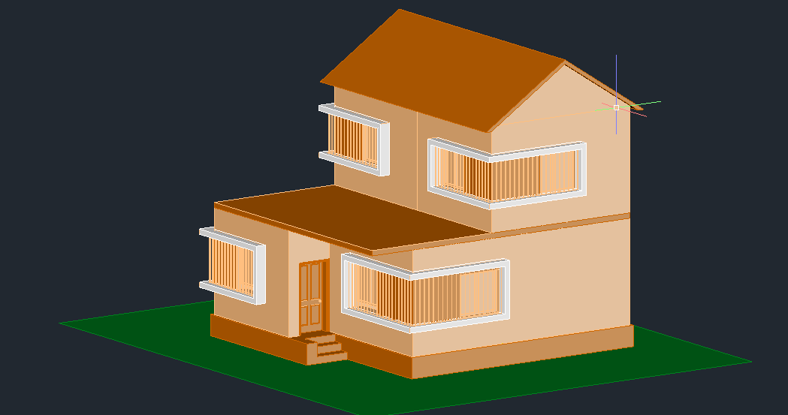

Specify second point or <use first point as displacement>:

Resuming MOVE command.

Specify second point or <use first point as displacement>:

Resuming MOVE command.

Specify second point or <use first point as displacement>:

Resuming MOVE command.

Specify second point or <use first point as displacement>:

Resuming MOVE command.

Specify second point or <use first point as displacement>:

Resuming MOVE command.

Specify second point or <use first point as displacement>:

Resuming MOVE command.

Specify second point or <use first point as displacement>:

Resuming MOVE command.

Specify second point or <use first point as displacement>:

Command:

Command: _copy

Select objects: Specify opposite corner: 3 found

Select objects:

Current settings: Copy mode = Multiple

Specify base point or [Displacement/mOde] <Displacement>:

Specify second point or [Array] <use first point as displacement>: <Ortho off>

Resuming COPY command.

Specify second point or [Array] <use first point as displacement>:

>>Enter new value for ORTHOMODE <0>:

Resuming COPY command.

Specify second point or [Array] <use first point as displacement>:

Resuming COPY command.

Specify second point or [Array] <use first point as displacement>:

Checking 561 intersections...

Specify second point or [Array/Exit/Undo] <Exit>: *Cancel*

Command:

Command:

Command: _-VIEW Enter an option [?/Delete/Orthographic/Restore/Save/sEttings/Window]: _TOP

Command: _rectang

Specify first corner point or [Chamfer/Elevation/Fillet/Thickness/Width]:

Specify other corner point or [Area/Dimensions/Rotation]:

Command: _u '.3DPAN2

Command: _u RECTANG GROUP

Command: _rectang

Specify first corner point or [Chamfer/Elevation/Fillet/Thickness/Width]:

Specify other corner point or [Area/Dimensions/Rotation]:

Command:

Command:

Command: _region

Select objects: Specify opposite corner: 1 found

Select objects:

1 loop extracted.

1 Region created.

Automatic save to C:\Users\Abdullah\AppData\Local\Temp\ED project_1_631_d01d485e.sv$ ...

Command: _move 1 found

Specify base point or [Displacement] <Displacement>:

Specify second point or <use first point as displacement>: 600

Command: _u

Command: _u MOVE GROUP

Command: _u GROUP menu item menu item menu item menu item

Command: _.zoom

Specify corner of window, enter a scale factor (nX or nXP), or

[All/Center/Dynamic/Extents/Previous/Scale/Window/Object] <real time>: _e

Command: _move

Select objects: 1 found

Select objects:

Resuming MOVE command.

Select objects:

Resuming MOVE command.

Select objects:

Resuming MOVE command.

Select objects:

Resuming MOVE command.

Select objects:

Specify base point or [Displacement] <Displacement>:

Resuming MOVE command.

Specify base point or [Displacement] <Displacement>:

Specify second point or <use first point as displacement>: <Ortho on> 600

.QUICKPROPERTIES

Command: *Cancel*

Crossing Lasso Press Spacebar to cycle options

Command: _.erase 1 found

Command: _move

Select objects: 1 found

Select objects: *Cancel*

Command: _move

Select objects: Specify opposite corner: *Cancel*

0 found

Select objects:

Resuming MOVE command.

Select objects: Specify opposite corner: 3 found

Select objects:

Resuming MOVE command.

Select objects:

Specify base point or [Displacement] <Displacement>:

Specify second point or <use first point as displacement>: <Ortho off>

Resuming MOVE command.

Specify second point or <use first point as displacement>:

Resuming MOVE command.

Specify second point or <use first point as displacement>:

Resuming MOVE command.

Specify second point or <use first point as displacement>:

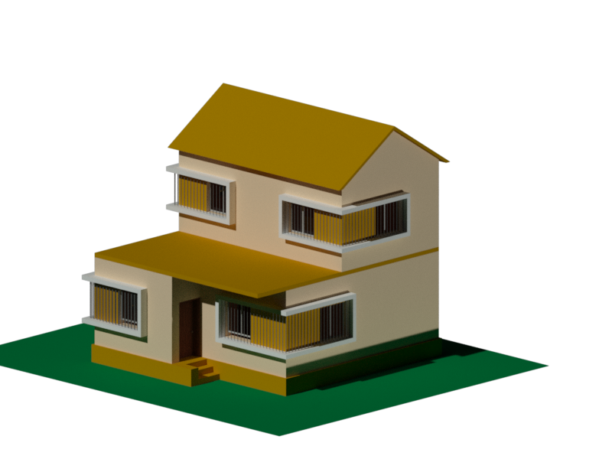

**THE END**